# OPTION A: TOTAL LENGTH= 1228 km (599+629)

**Tyrrhenian- Apennines section**

9.99 E, 39.94 N

14.55 E, 39.93 N

16.11 E, 41.36 N

--

# Adriatic Sea-Dinarides Section

17.24 E, 41.00 N

19.35 E, 43.50 N

21.74 E, 43.49 N

22.89 E, 43.98 N

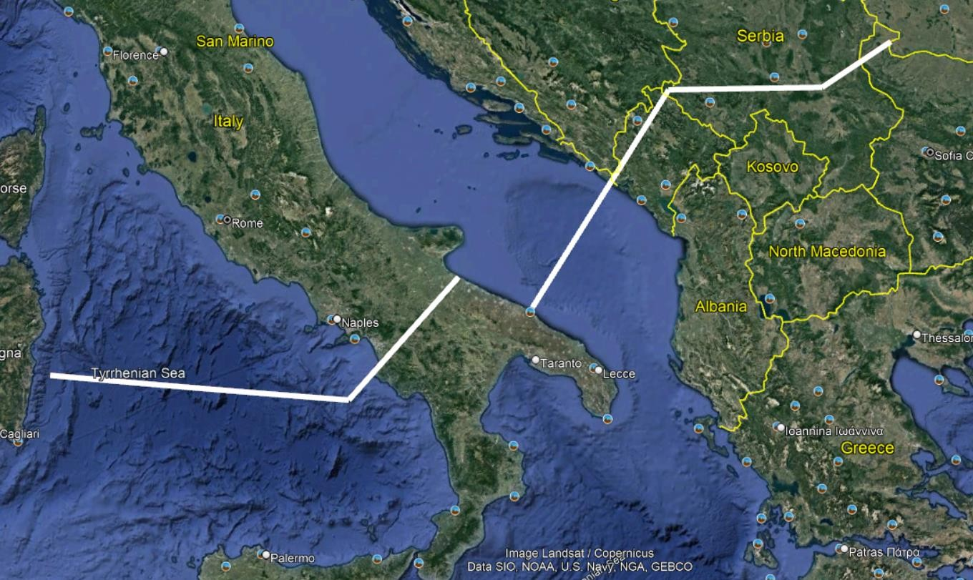

Option A

# 

# OPTION B: TOTAL LENGTH= 1243 km ( 599+195+449 km)

**Tyrrhenian- Apennines section**

9.99 E, 39.94 N

14.55 E, 39.93 N

16.11 E, 41.36 N

--

# Adriatic Sea section

16.62 E, 41.22 N

17.94 E, 42.67 N

--

# Dinarides section

18.33 E, 42.39N

19.33 E, 43.50 N

21.74 E, 43.49 N

22.88 E, 43.98 N

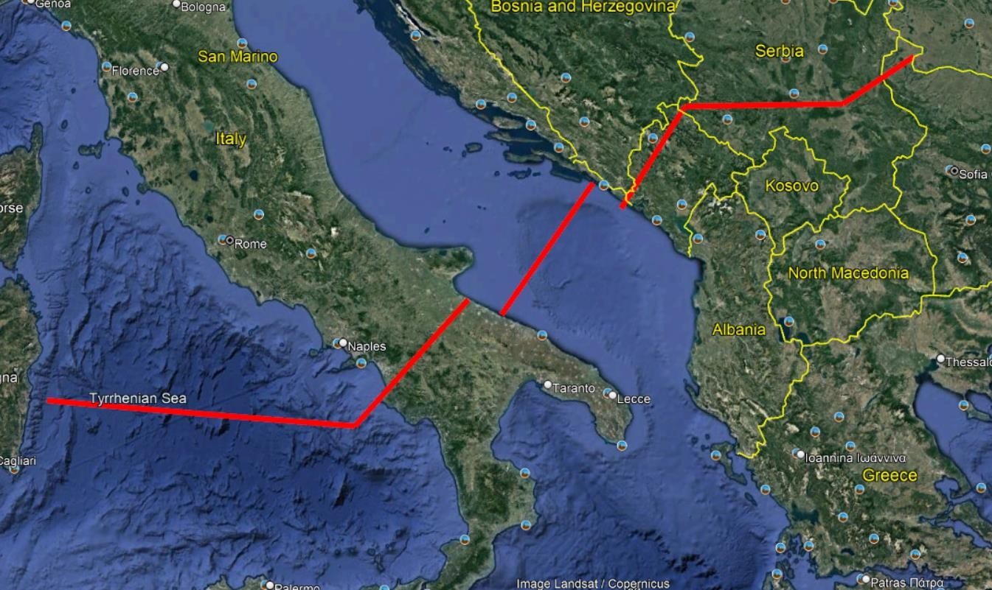

# 

# OPTION C → Connected sections: TOTAL LENGTH= 1264 KM

9.98 E, 39.94 N

14.54 E, 39.94 N

14.95 E, 40.32 N

16.14 E, 41.39 N

18.36 E, 42.39 N

19.33 E, 43.50 N

21.73 E, 43.49 N

22.88 E, 43.98 N

